
AMRITA SCHOOL OF ARTIFICIAL INTELLIGENCE

23AIE232M: Python for AI
END SEMESTER VIEW REPORT

COST ESTIMATION FOR CONSTRUCTION PROJECT

Submitted by

DEPARTMENT OF CIVIL ENGINEERING
CB.EN.U4CIE23009 | Bhumika Arya
CB.EN.U4CIE23031 | Parvana S
CB.EN.U4CIE23042 | Sri Akshaya AN
CB.EN.U4CIE23044 | Varun Kumar B
CB.EN.U4CIE23056 | Mukunthan S

MARKS FACULTY IN-CHARGE

AMRITA SCHOOL OF ENGINEERING
AMRITA VISHWA VIDYAPEETHAM
COIMBATORE - 641 112


BONAFIDE CERTIFICATE

This is to certify that the Project entitled “COST ESTIMATION FOR CONSTRUCTION PROJECT” submitted by Bhumika Arya (CB.EN.U4CIE23009), Parvana S (CB.EN.U4CIE230031), Sri Akshaya AN (CB.EN.U4CIE23042),Varun Kumar (CB.EN.U4CIE23009), Mukunthan S (CB.EN.U4CIE23056), for the award of the Degree of Minor course in the “Artificial Intelligence and Machine Learning- PYTHON FOR AI” is a bonafide record of the work carried out by them under my guidance and supervision at Amrita School of Engineering, Coimbatore.

Name of the Guide(s)
Ms. Chandni

Submitted for the university examination held on ... ... ... ... ... ...

INTERNAL EXAMINER EXTERNAL EXAMINER

AMRITA SCHOOL OF ENGINEERING
AMRITA VISHWA VIDYAPEETHAM
COIMBATORE - 641 112

DECLARATION

We, Bhumika Arya (CB.EN.U4CIE23009), Parvana S (CB.EN.U4CIE230031), Sri Akshaya AN (CB.EN.U4CIE23042), Varun Kumar B (CB.EN.U4CIE23044), Mukunthan S (CB.EN.U4CIE23056), hereby declare that this project entitled “Cost estimation for construction project”, is the record of the original work done by us under the guidance of Ms. Chandni and Mr. Yadukrishnan.

Place: Coimbatore
Date: 20-04-2025

COUNTERSIGNED

Dr. K.P.Soman
Dean of Artificial Intelligence
Head Center for Computational Engineering and Networking

Contents

Acknowledgement 5
List of Abbreviations 6
Abstract 7

Introduction 8

- Literature Survey

- Problem statement

- Objectives

Background 9

Uniqueness of the project 10

Technologies and Libraries 11

Proposed Work 13

- Methodology

- Code and output

- Github link

Conclusion 37

Reference 37

ACKNOWLEDGEMENT

We would like to express our sincere gratitude to Ms. Chandni, Faculty teacher of Python for AI, for her unwavering support and guidance throughout this project. We extend our gratitude to Mr. Yadukrishnan and also wish to express our appreciation to the Dean of the Department of Artificial Intelligence Dr. K.P.Soman for providing us with this valuable opportunity. Furthermore, we are thankful to our teammates for their dedicated efforts and encouragement, which were instrumental in the completion of this paper. This endeavor would not have been possible without the contributions of each of these individuals.

Bhumika Arya
Parvana S
Sri Akshaya AN
Varun Kumar
Mukunthan S

List of Abbreviations:

Abbreviation | Full Form
AI | Artificial Intelligence
ML | Machine Learning
GUI | Graphical User Interface
SQL | Structured Query Language
EDA | Exploratory Data Analysis
MSE | Mean Squared Error
MAE | Mean Absolute Error
R² | Coefficient of Determination
CSV | Comma Separated Values
DB | Database

Abstract
This project aims to develop a personalized cost estimation system utilizing machine learning and SQL databases to predict the most accurate construction costs based on critical parameters such as material costs, labour costs, project size, and historical data.
The system will store and manage data using MySQL, ensuring efficient retrieval and processing.
A Linear Regression model is trained using Scikit-Learn will analyse past project costs and predict future estimates.
Tkinter-based GUI is implemented to allow real-time user input.
The results will be presented through an interactive interface featuring graphical cost breakdowns and visual representations using Matplotlib.
The system automatically inserts predicted results into a MySQL database, making the solution interactive, scalable, and industry ready.

Introduction
Literature Review: Advancements in Cost Estimation for Construction Projects
Cost estimation in construction has evolved significantly, integrating machine learning, AI, and database-driven approaches to improve accuracy and efficiency. Traditional methods often rely on manual calculations, historical data, and predefined formulas, whereas modern advancements leverage big data, predictive analytics, and automation for better cost forecasting.
1. Database-Driven Cost Estimation
Relational databases like MySQL play a crucial role in storing and managing large-scale construction cost data. Studies by Patil, Deshmukh, and Mehta (2023) emphasize the efficiency of SQL-based systems in retrieving and analyzing past project costs. Sinha, Verma, and Kapoor (2022) discuss the integration of cloud-based databases for real-time cost estimation, allowing dynamic updates and scalability.
2. Machine Learning for Cost Prediction
Machine learning models, particularly Linear Regression, are widely applied in cost estimation. Gupta, Sharma, and Reddy (2021) demonstrate the effectiveness of regression models in predicting total project costs based on material, labor, and project size. Sharma, Iyer, and Bansal (2023) explore the use of Random Forest and Gradient Boosting to enhance prediction accuracy beyond traditional regression models.
Neural networks and deep learning are emerging trends in cost estimation. Lee, Park, and Wong (2024) utilize artificial neural networks (ANNs) for complex cost predictions, highlighting their ability to learn nonlinear relationships between cost factors.
3. Cost Estimation with AI and Big Data
Big data analytics in construction cost estimation is gaining momentum. Ramesh, Kulkarni, and Nair (2022) propose a hybrid model combining big data with AI to analyze cost variations across multiple projects. Kumar, Patel, and Choudhary (2023) explore the role of Natural Language Processing (NLP) in analyzing cost-related documents, improving decision-making accuracy.
4. Visualization and Decision Support Systems
Visual representation of cost trends enhances decision-making. Agarwal, Dutta, and Joshi (2023) integrate Matplotlib and Power BI for cost visualization, enabling stakeholders to interpret project costs through graphs, heatmaps, and predictive trend analysis.

Problem Statement:
Many existing cost estimation methods are either manual, prone to errors, or lack real-time adaptability. While some tools offer cost predictions, they often fail to integrate machine learning techniques for improved accuracy. Additionally, many solutions are not openly accessible or lack an intuitive user experience for construction professionals.

Objective:
- To develop an AI-powered cost estimation model using machine learning and SQL.
- To provide an accurate, efficient, and scalable cost prediction system.
- To ensure a user-friendly interface (UI) with clear cost breakdowns and secure data storage.
Scope:
- Can be implemented in real-time applications for construction firms and contractors.
- Can be expanded with advanced regression models and AI-powered optimizations.
- Can integrate with construction management software for end-to-end budgeting solutions.

Background
For all construction professionals, developers, and project managers, accurate cost estimation is a crucial factor in ensuring project success. This system aims to provide a personalized and data-driven cost estimation platform, reducing the risks of budget overruns and inaccurate financial planning. By leveraging machine learning, AI, and SQL, this system will offer precise cost predictions based on historical data and key project parameters.

Uniqueness of the Project
- Real-Time Cost Prediction
Uses a Linear Regression model to predict construction costs based on user input.
- Interactive GUI (Tkinter)
Provides a user-friendly interface for real-time data entry and predictions.
- Database Integration
Automatically stores predictions in a MySQL database for continuous dataset growth.
- Customizable Input Parameters
Allows users to input material costs, labor, profit, discounts, and policies for personalized predictions.
- Feature Engineering & Visual Insights
Includes one-hot encoding and visualizations like heatmaps and scatter plots for better data understanding.
- Scalable & Deployable
Can be expanded with more models or deployed as a desktop/web tool for the construction industry.
- Modular Design
Follows modular coding practices for easy future enhancements and academic use.

Technologies and Libraries:
1. Database Management System: MySQL
- MySQL is a popular open-source relational database management system.
- It is widely used for storing and managing large datasets.
- MySQL supports SQL, which is used to retrieve data from the database.

2. Programming Language: Python
- Python is a high-level, interpreted programming language.
- It is widely used for data analysis, machine learning, and web development.
- Python has extensive libraries for data manipulation, visualization, and machine learning.

3. Data Manipulation Library: Pandas
- Pandas is a popular Python library for data manipulation and analysis
It provides data structures such as Series (1-dimensional labeled array) and DataFrame (2-dimensional labeled data structure with columns of potentially different types).
- Pandas is used to retrieve data from the MySQL database, manipulate the data, and prepare it for machine learning.

4. Machine Learning Library: Scikit-learn
- Scikit-learn is a popular Python library for machine learning.
- It provides a wide range of algorithms for classification, regression, clustering, and other tasks.
- Scikit-learn is used to train a machine learning model on the dataset to estimate the cost of buildings.

5. Data Visualization Library: Matplotlib and Seaborn
- Matplotlib and Seaborn are popular Python libraries for data visualization.
- They provide a wide range of visualization tools, including plots, charts, and heatmaps.
- Matplotlib and Seaborn are used to visualize the dataset and the estimated cost of buildings

6. SQL Library: mysql-connector-python
- mysql-connector-python is a Python library that allows you to connect to a MySQL database.
- It provides a way to execute SQL queries and retrieve data from the database.
- mysql-connector-python is used to retrieve data from the MySQL database.

7. Graphical User Interface (GUI): Tkinter
- Tkinter is a built-in Python library for creating graphical user interfaces.
- It allows the development of user-friendly interfaces with buttons, text fields, and other elements.
- Tkinter is used to build the GUI for real-time user interaction, allowing easy input of data and displaying predicted costs.
The technologies and libraries listed above provide a comprehensive framework for estimating the cost of buildings using machine learning. MySQL is used to store and manage the dataset, Python is used for data manipulation and machine learning, and Matplotlib and Seaborn are used for data visualization. Scikit-learn is used to train a machine learning model on the dataset, and mysql-connector-python is used to retrieve data from the MySQL database. Additionally, Tkinter is used to create a user-friendly graphical interface, allowing real-time data input and instant cost prediction, making the system accessible for non-technical users.

Proposed Work
Methodology:
The methodology for this project involves the following steps:

1. Data Collection:
- The dataset was initially collected online in csv format https://www.kaggle.com/datasets/sasakitetsuya/construction-estimation-data?resource=download
- The data was then imported into a MySQL database.
- The dataset contains features such as material cost, labor cost, profit rate, discount or markup, policy reason, and estimate.
- The dataset is retrieved from the MySQL database using SQL queries.

2. Data Preprocessing:
- The data was retrieved into a Pandas DataFrame.
- The dataset is cleaned and preprocessed by handling missing values, removing duplicates, and converting data types.
- One-hot encoding was applied to categorical data (Policy_Reason) to convert it into numerical format.
- Null checks and column alignment were performed to ensure clean training data.

3. Exploratory Data Analysis (EDA):
- The preprocessed dataset is analyzed using statistical methods and visualization tools.
- Used Pandas, Matplotlib, and Seaborn to plot histograms, heatmaps, and correlation matrices.
- Helped identify relationships between features and the target variable (Total_Estimate).
- The EDA helps to identify patterns, trends, and correlations in the dataset.

4. Feature Engineering:
- The dataset is transformed and feature engineered to improve the performance of the machine learning model.
- Applied one-hot encoding on Policy_Reason.
- Selected key features such as Material Cost, Labor Cost, Profit Rate, and Discount/Markup.
- The feature engineered dataset is used to train the machine learning model.

5. Model Building:
- A machine learning model is trained on the feature engineered dataset.
- The model is trained using a suitable algorithm linear regression.
- The model was trained on historical data to learn patterns in construction cost estimation.

6. Model Evaluation:
- The trained model is evaluated on a test dataset.
- Evaluation metrics used include Mean Squared Error (MSE), Mean Absolute Error (MAE), and R² Score.
- Plotted Actual vs Predicted costs to visualize model accuracy.
- The model is fine-tuned and hyperparameters are adjusted to improve the performance.

7. GUI Development and Integration:
- Built a Tkinter-based interface for real-time user input.
- User data is used to generate predictions which are then displayed in the GUI.
- Each prediction is also stored in the MySQL database, automatically increasing the dataset size.

8. Deployment:
- The trained model is deployed in a production-ready environment.
- The model is integrated with a user interface to accept input features and predict the cost of buildings.
- The model is monitored and updated regularly to maintain its performance and accuracy.

9. Maintenance:
- The model is maintained and updated regularly to adapt to changes in the dataset and market trends.
- The model is retrained and reevaluated periodically to ensure its performance and accuracy.
- The model is documented and knowledge is transferred to stakeholders to ensure continuity.

By following this methodology, we can develop a reliable and accurate machine learning model for estimating the cost of buildings.

10. GitHub account:
- The complete source code, dataset, trained model, GUI application, and project documentation are maintained in a dedicated GitHub repository:
https://github.com/bhumikaghub71123/AIML_grp_1_Endsem_Project

Codes & Outputs
1. Inserting data to MYSQL
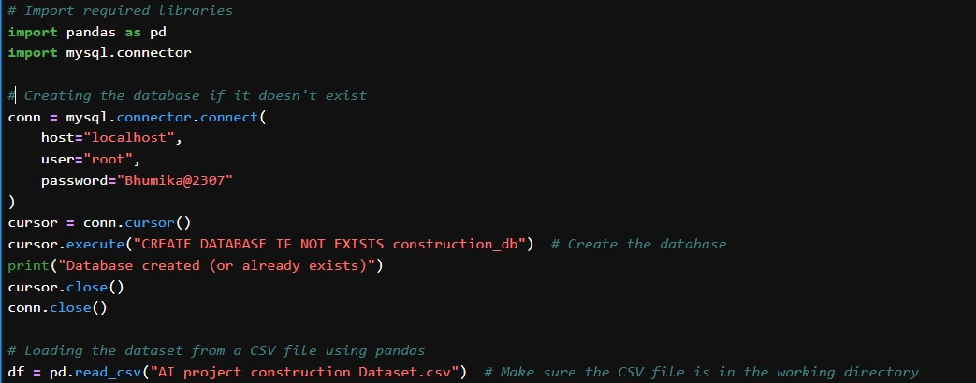
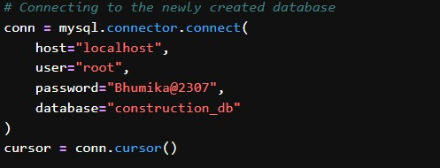
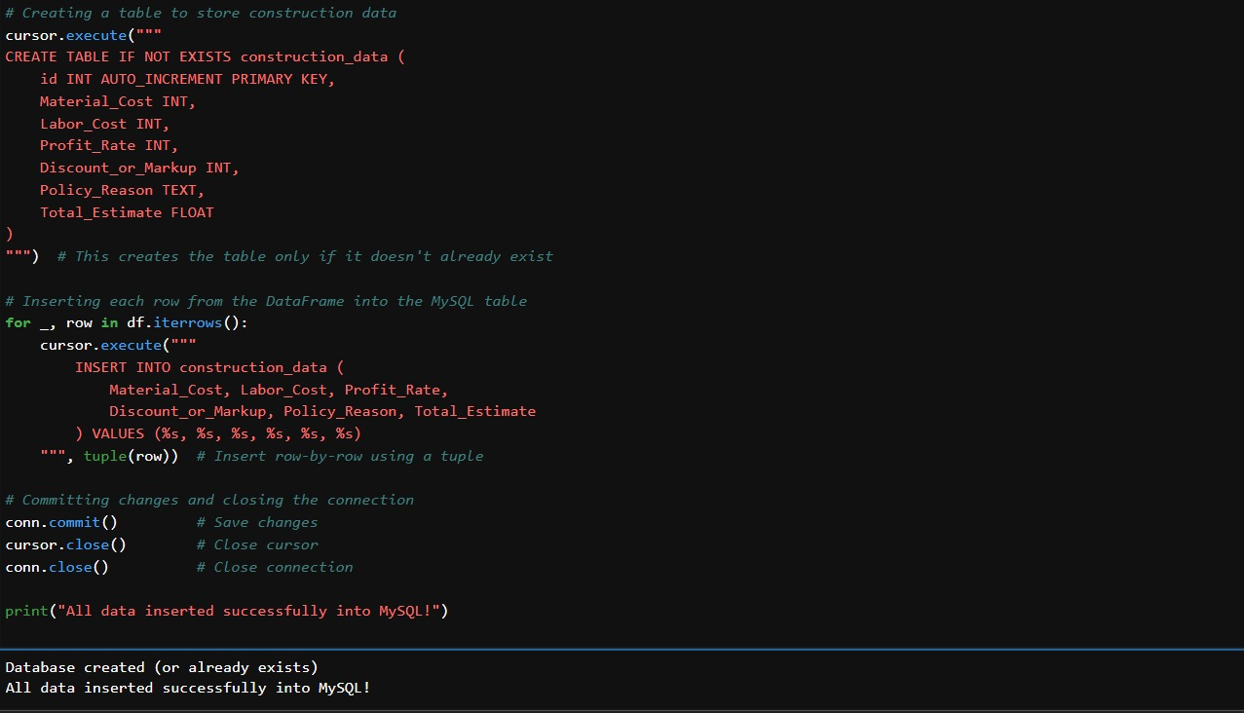
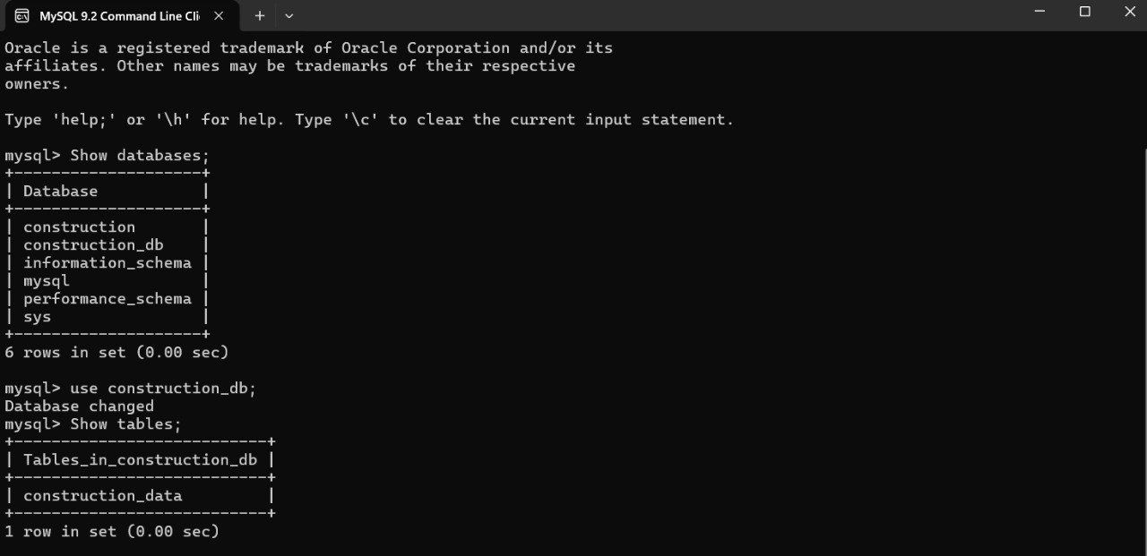
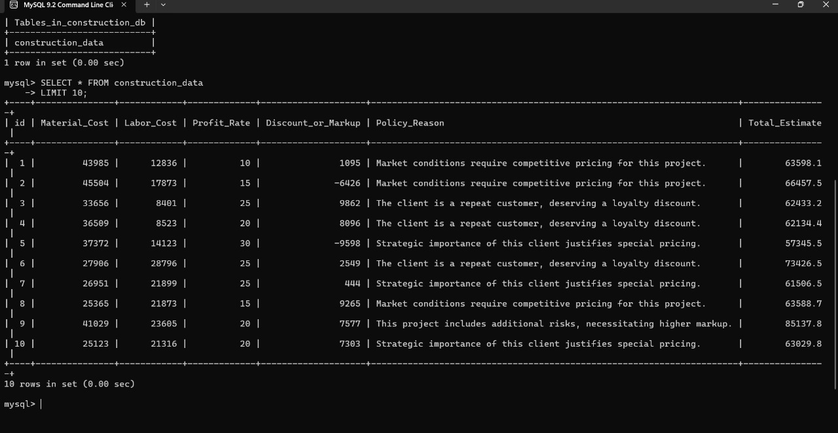

2. Connecting through MySQL Alchemy and retrieving data
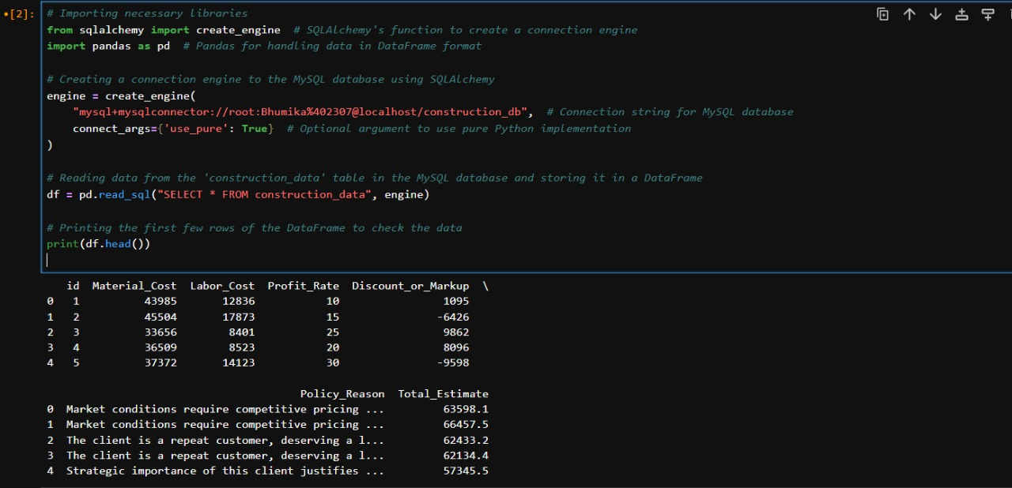

3. Plotting Graphs and Heatmaps
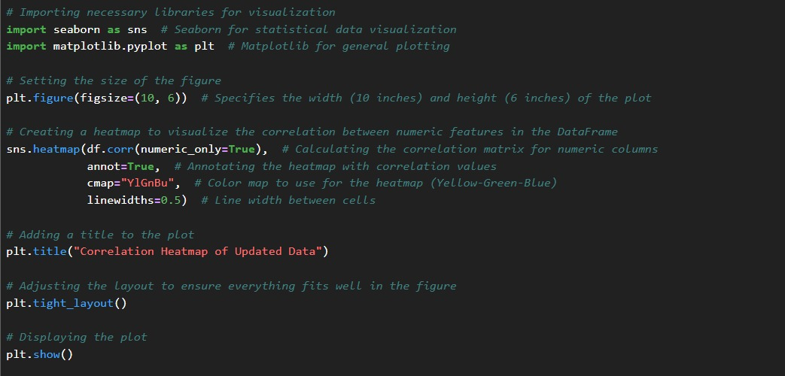

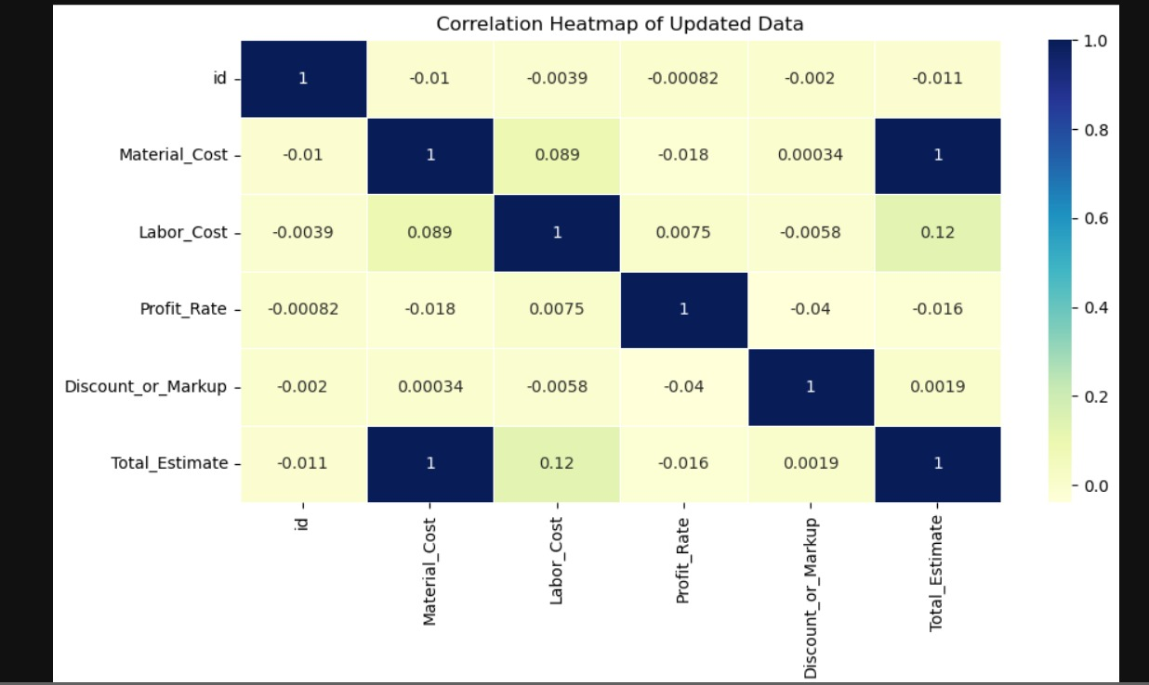

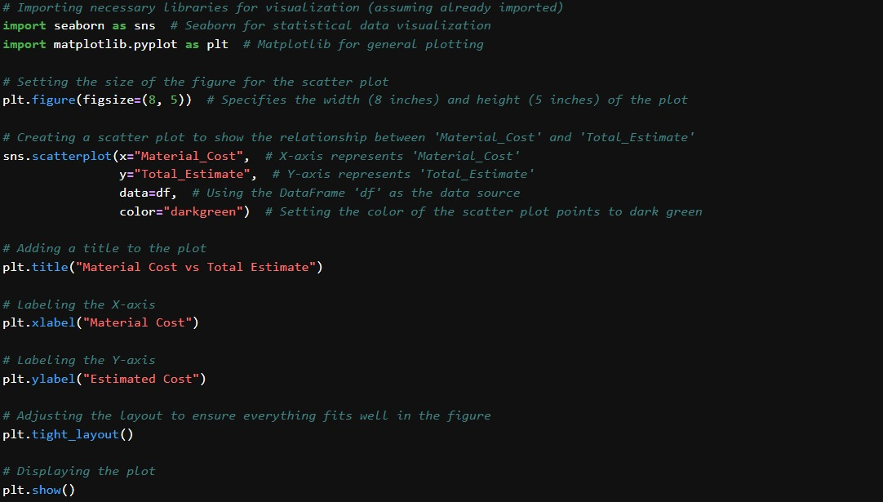

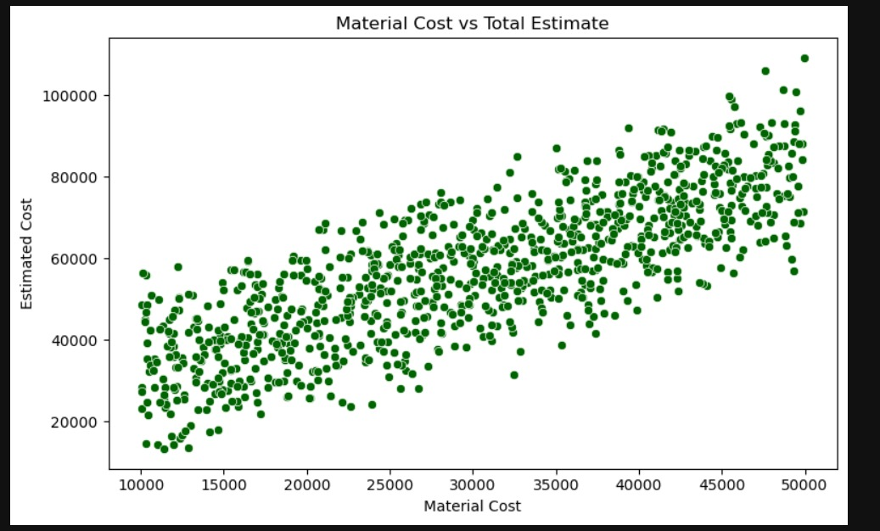
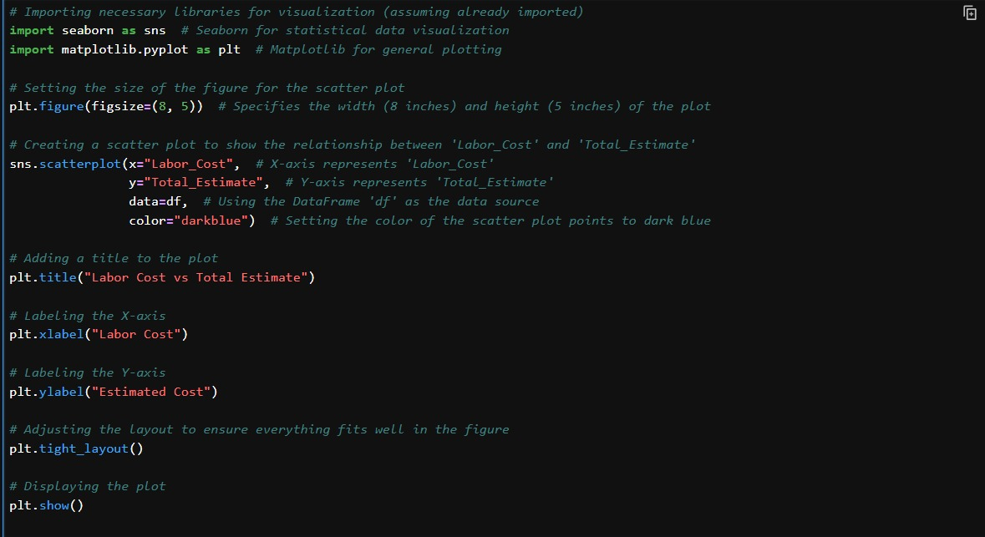
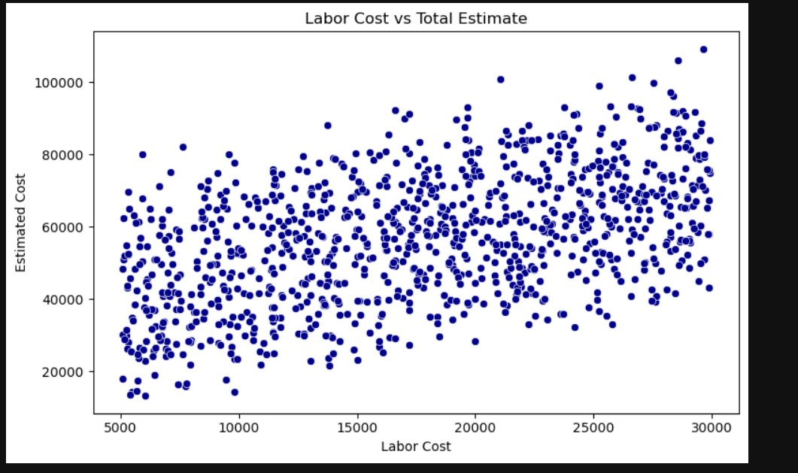
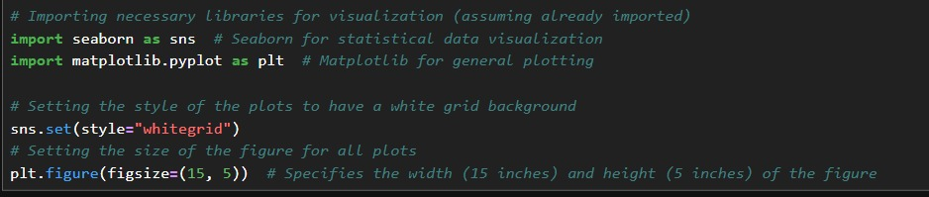
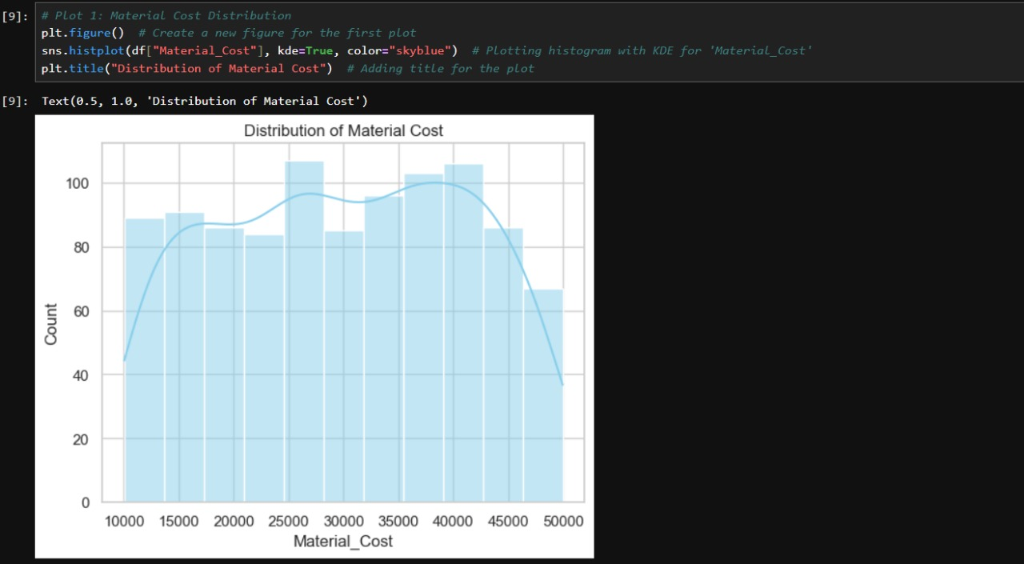
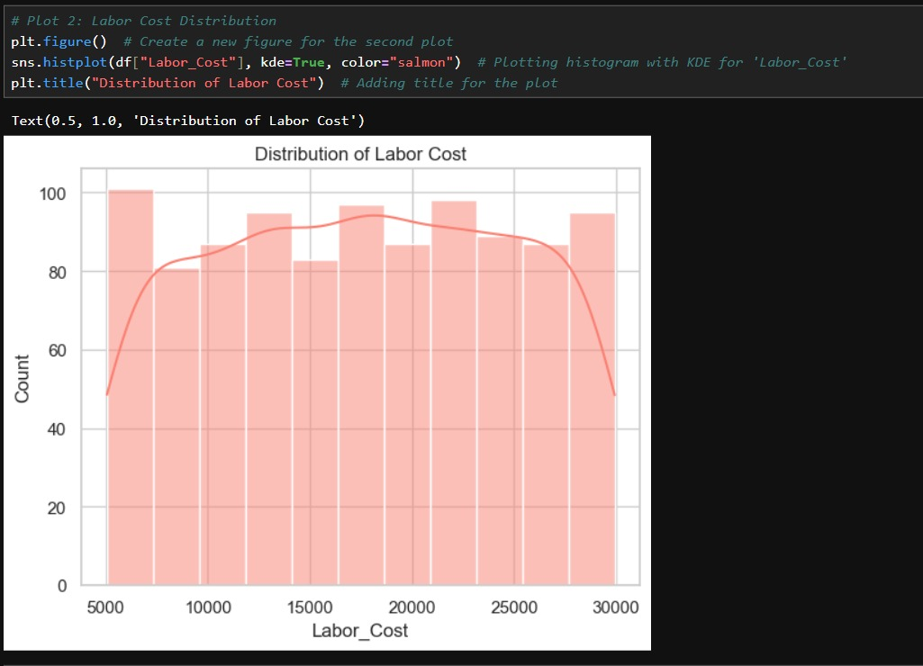
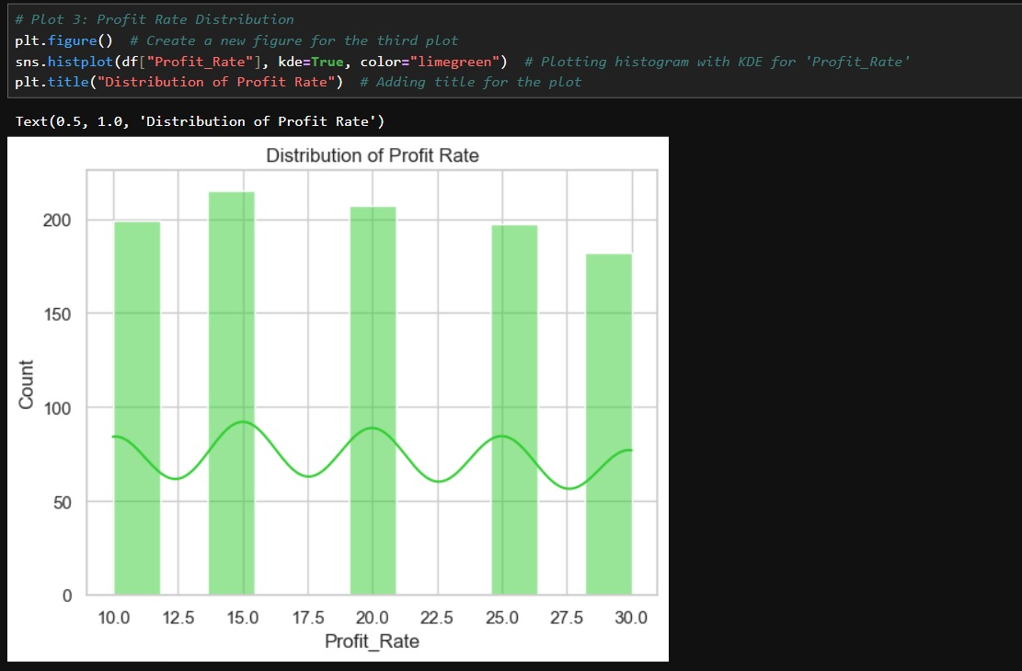
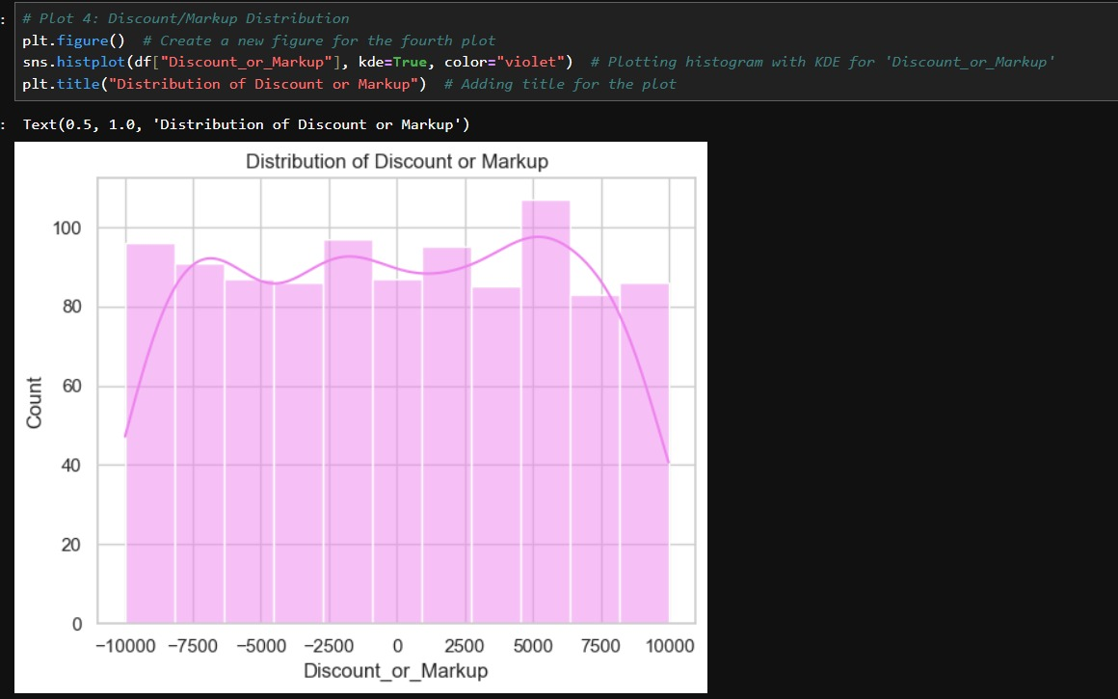

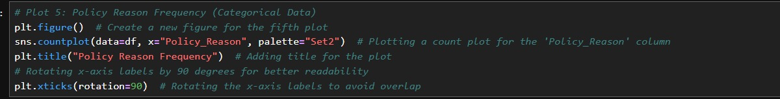
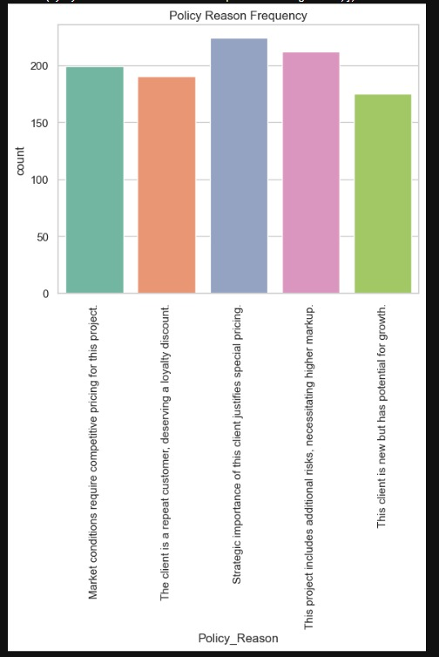

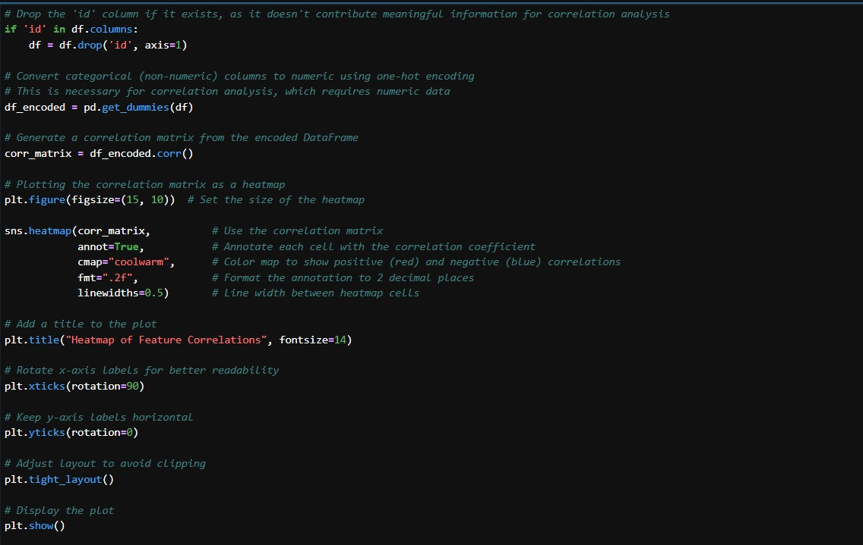
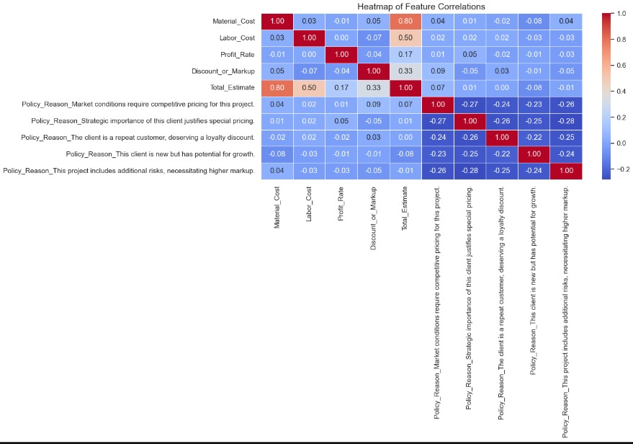

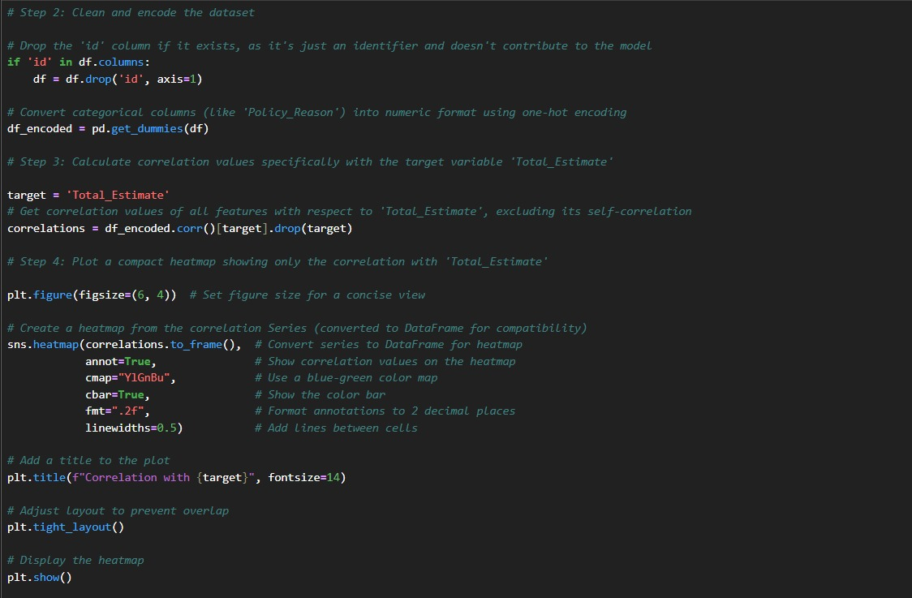
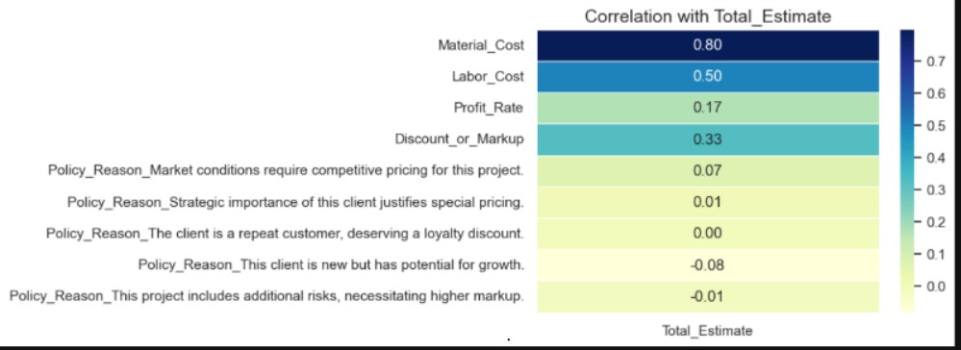

4. Training the model
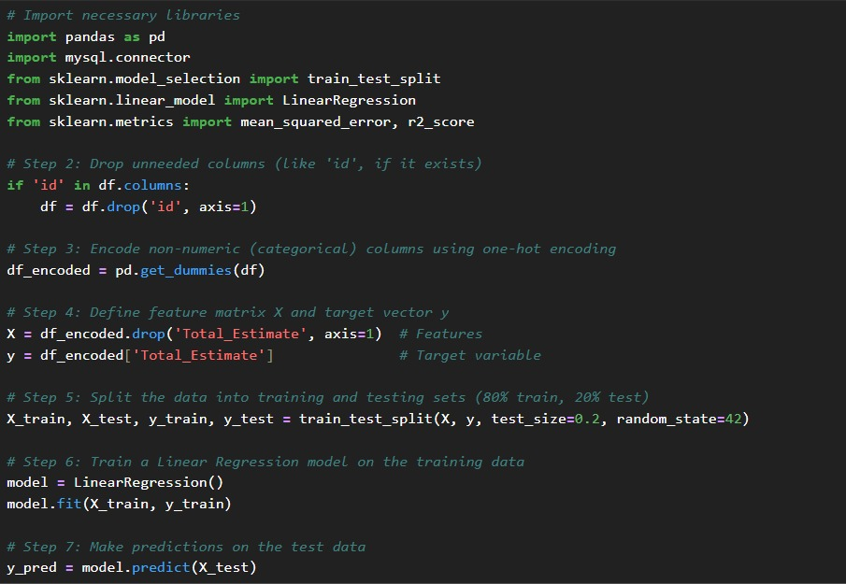
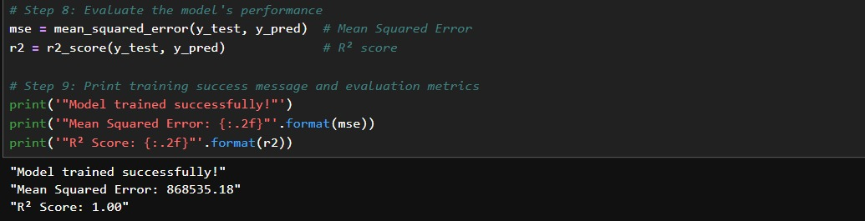

5. Predicting output for new data
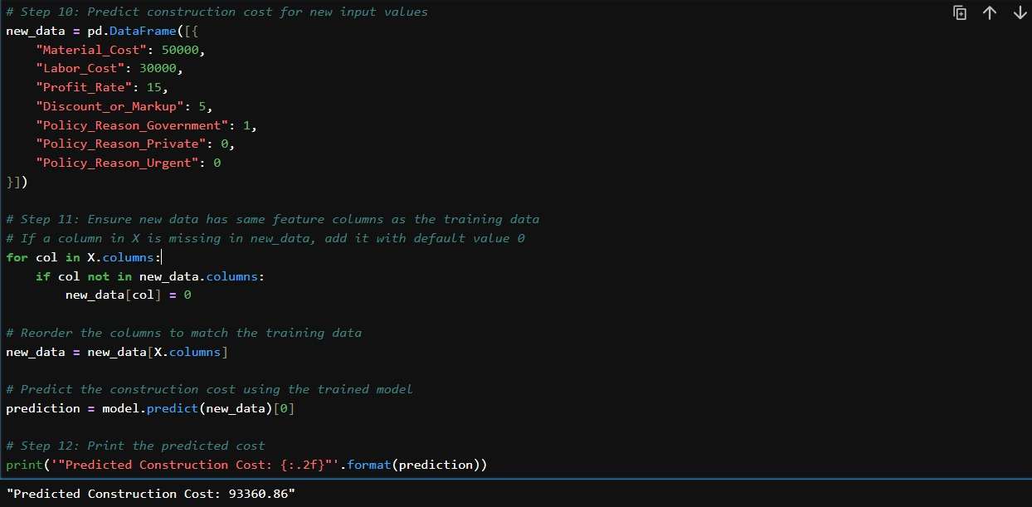

6. Creating user input

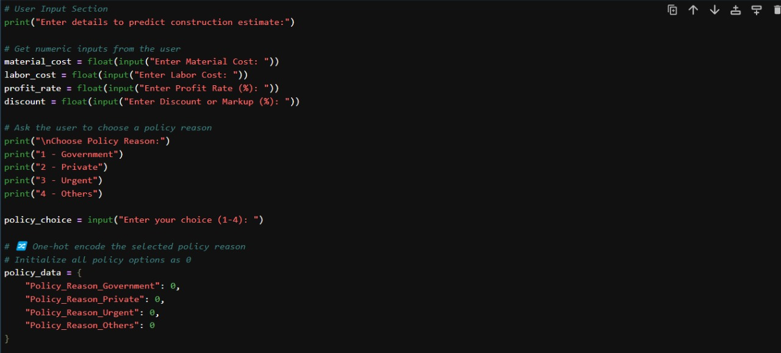

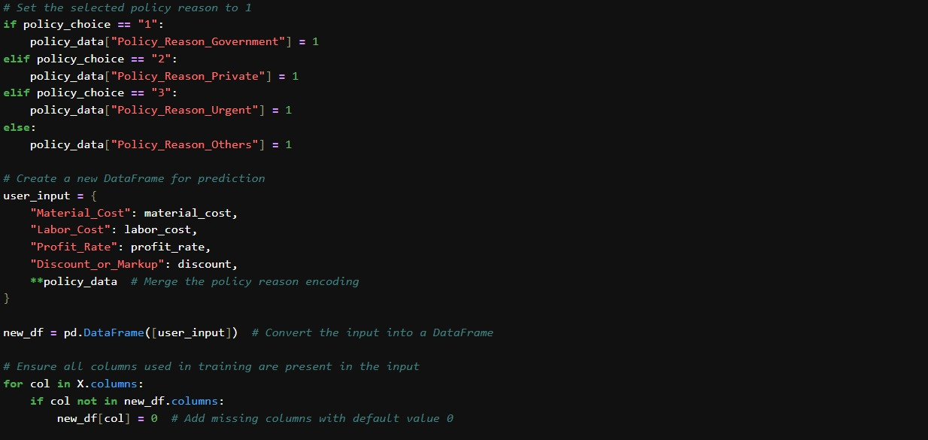

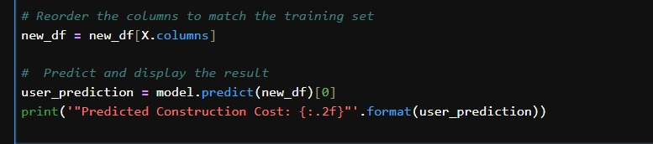
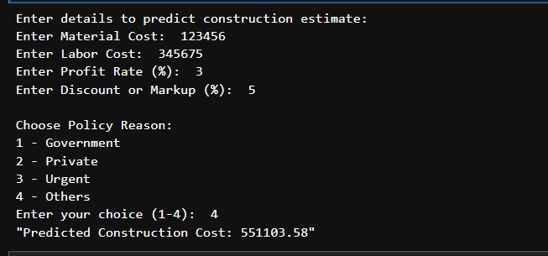

7. Creating graphical user interface
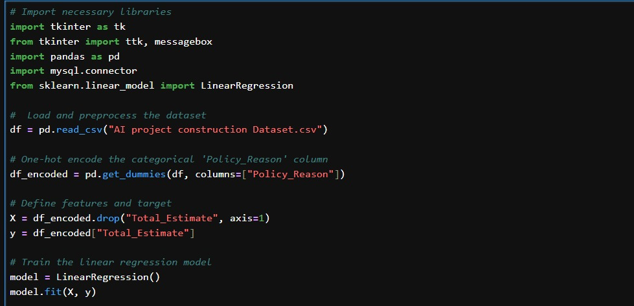
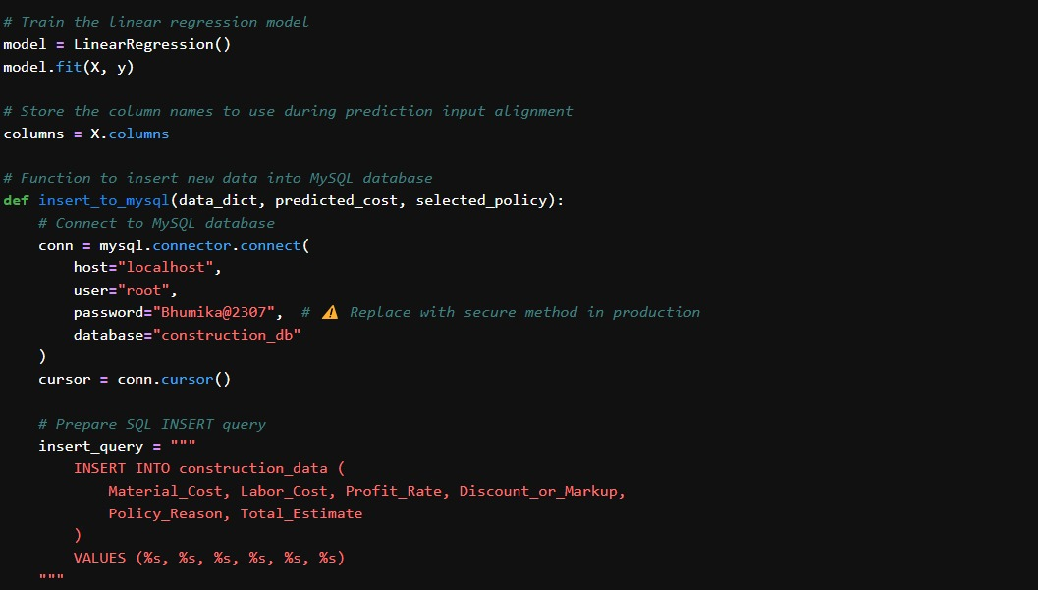
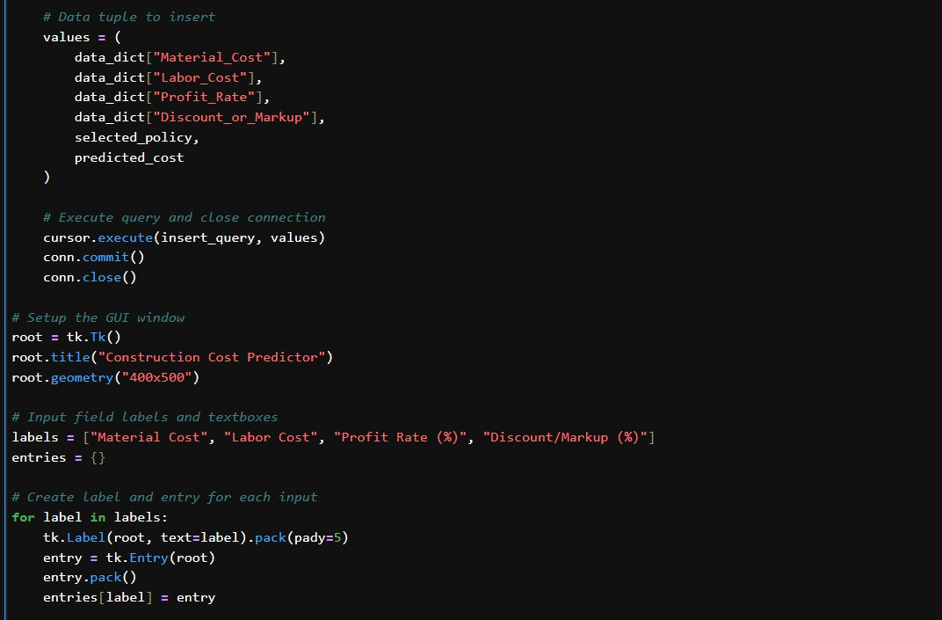
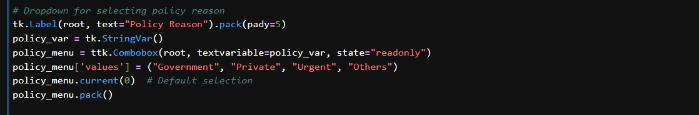
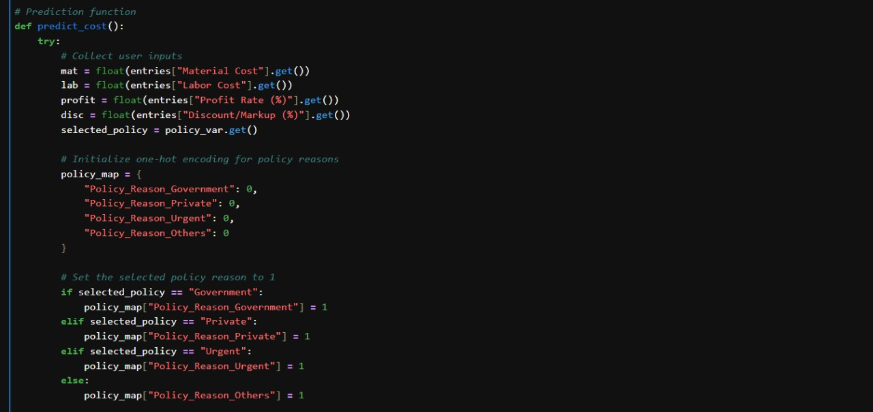
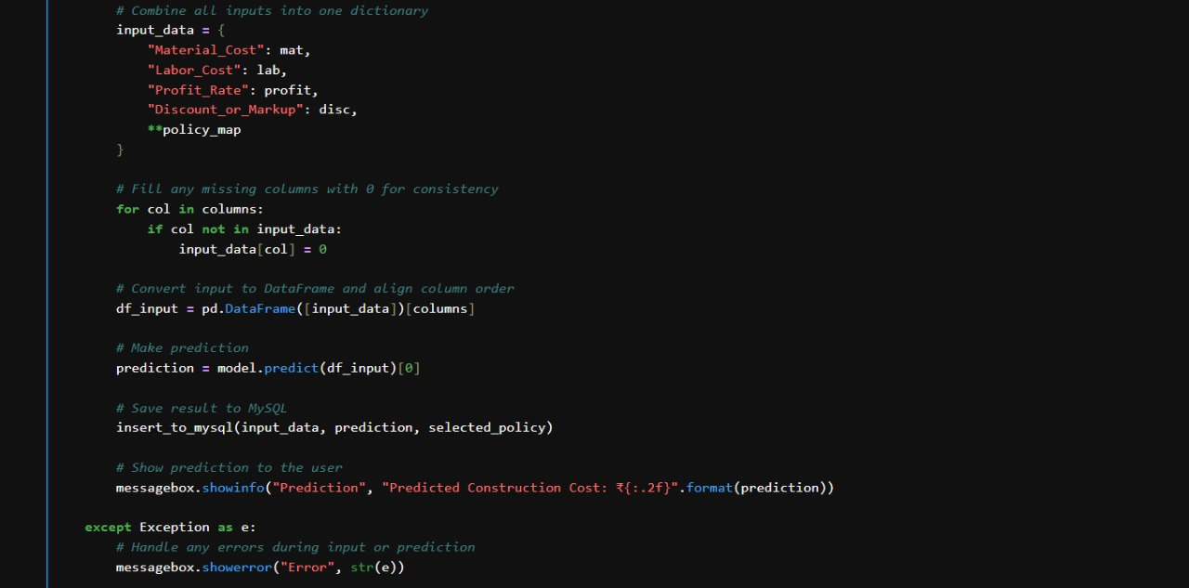

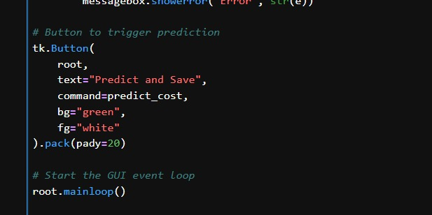

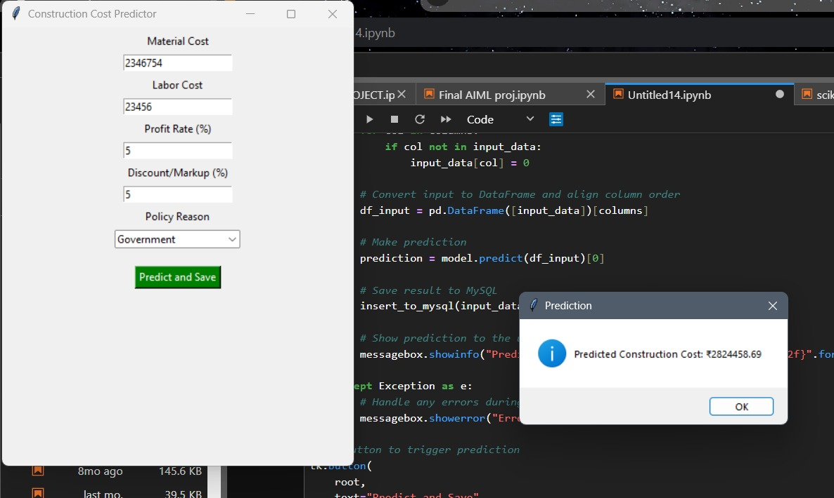

8. Comparing actual and predicted output
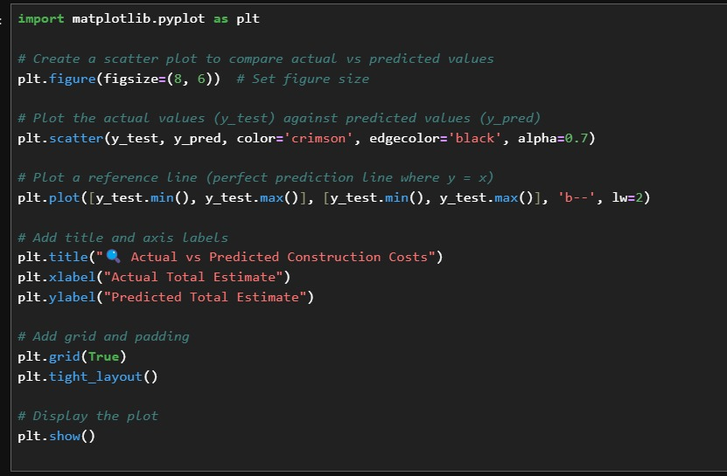

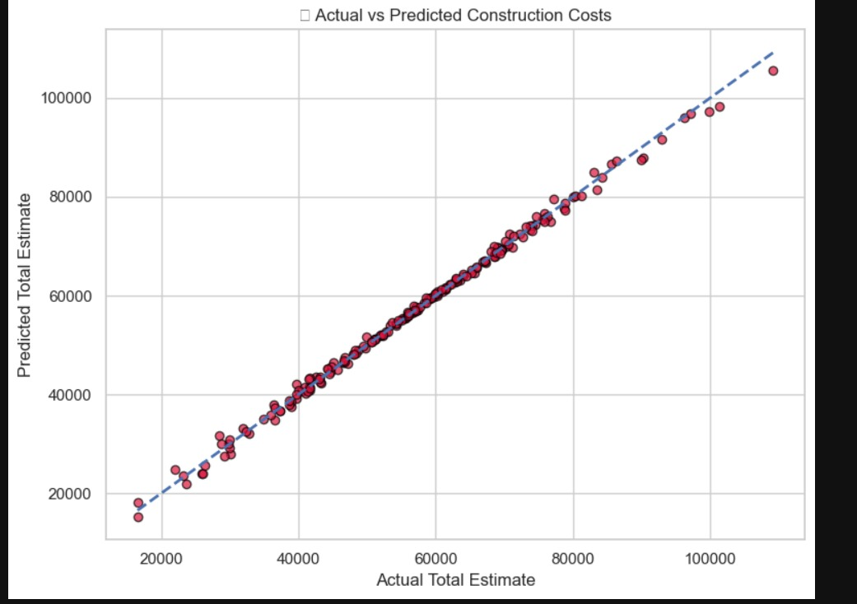

9. Evaluating the model
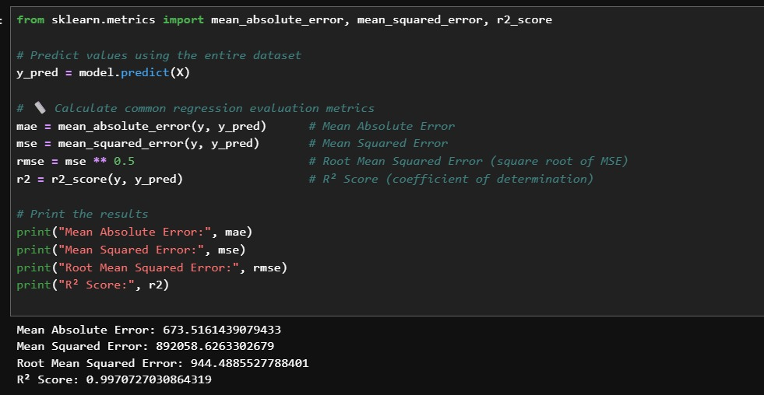

GitHub Link
https://github.com/bhumikaghub71123/AIML_grp_1_Endsem_Project

Conclusion
- Successfully integrated MySQL for structured data storage and efficient retrieval. MySQL has been effectively utilized for structured data storage, ensuring seamless retrieval and manipulation.
- A Linear Regression model has been trained to accurately predict construction costs, based on user-provided data and historical records.
- A user-friendly interface using Tkinter has been developed, allowing real-time user input and instant cost predictions.
- Tools like Matplotlib and Seaborn have been leveraged to provide visual insights, such as heatmaps and correlation graphs, aiding decision-making.
- Identified and addressed challenges like data quality issues and computational constraints.
- Future work includes feature engineering, model evaluation, and real-world deployment.

References
https://scikit-learn.org
https://dev.mysql.com/doc/
https://matplotlib.org/stable/contents.html
www.youtube.com
www.chatgpt.com
www.google.com

